**1.Hibernate**

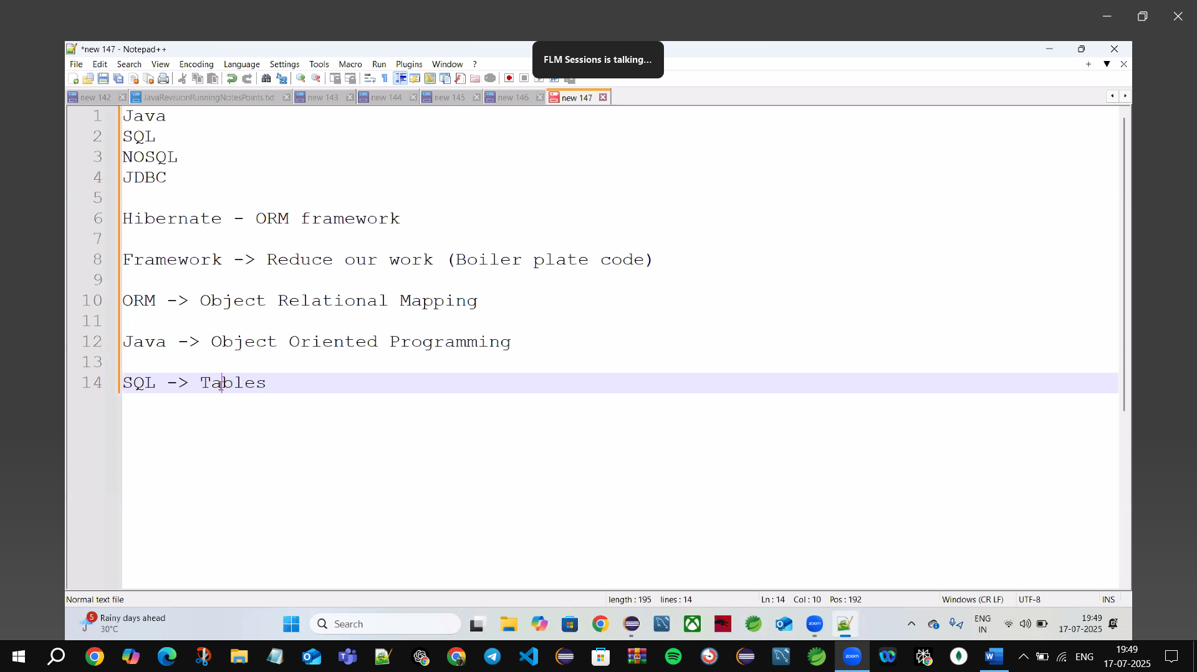

Hibernate🡪it’s a ORM Framework

Framework🡪which is reduce our work

Boiler Plate code🡪Ready-made code (In-Built code)

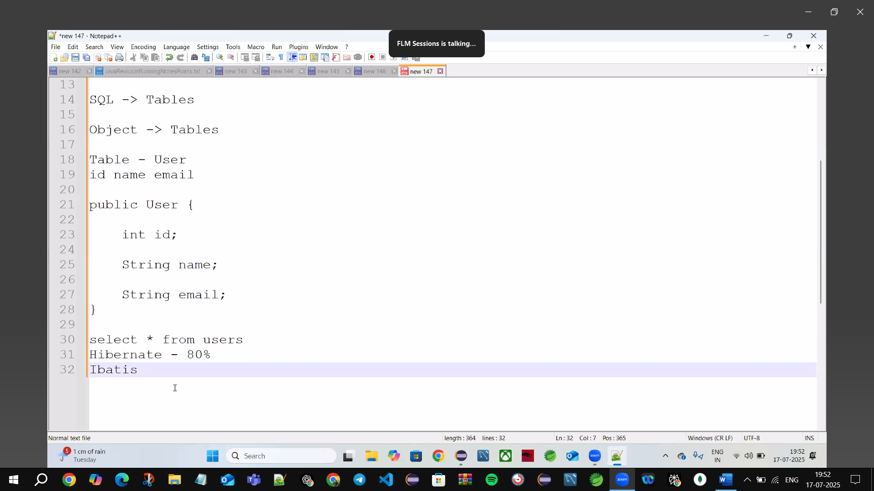

Boiler plate🡪Ready-made code

Java🡪Objects

**ORM🡪Object Relational Mapping**

SQL🡪Tables

**🡪ORM maps🡪 Java Object to + SQL Tables**

🡪**ORM: -** **Map Java Class to 🡪SQL Tables**

🡪80% we use Hibernate in Real-time applications

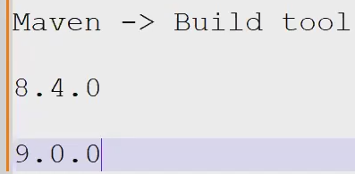

**Build Tool🡪Manages the Dependencies**

**Eg: Maven, Gradle etc.**

**Create Maven Project🡪File next🡪Maven Project🡪Create Simple project🡪Configure Project**

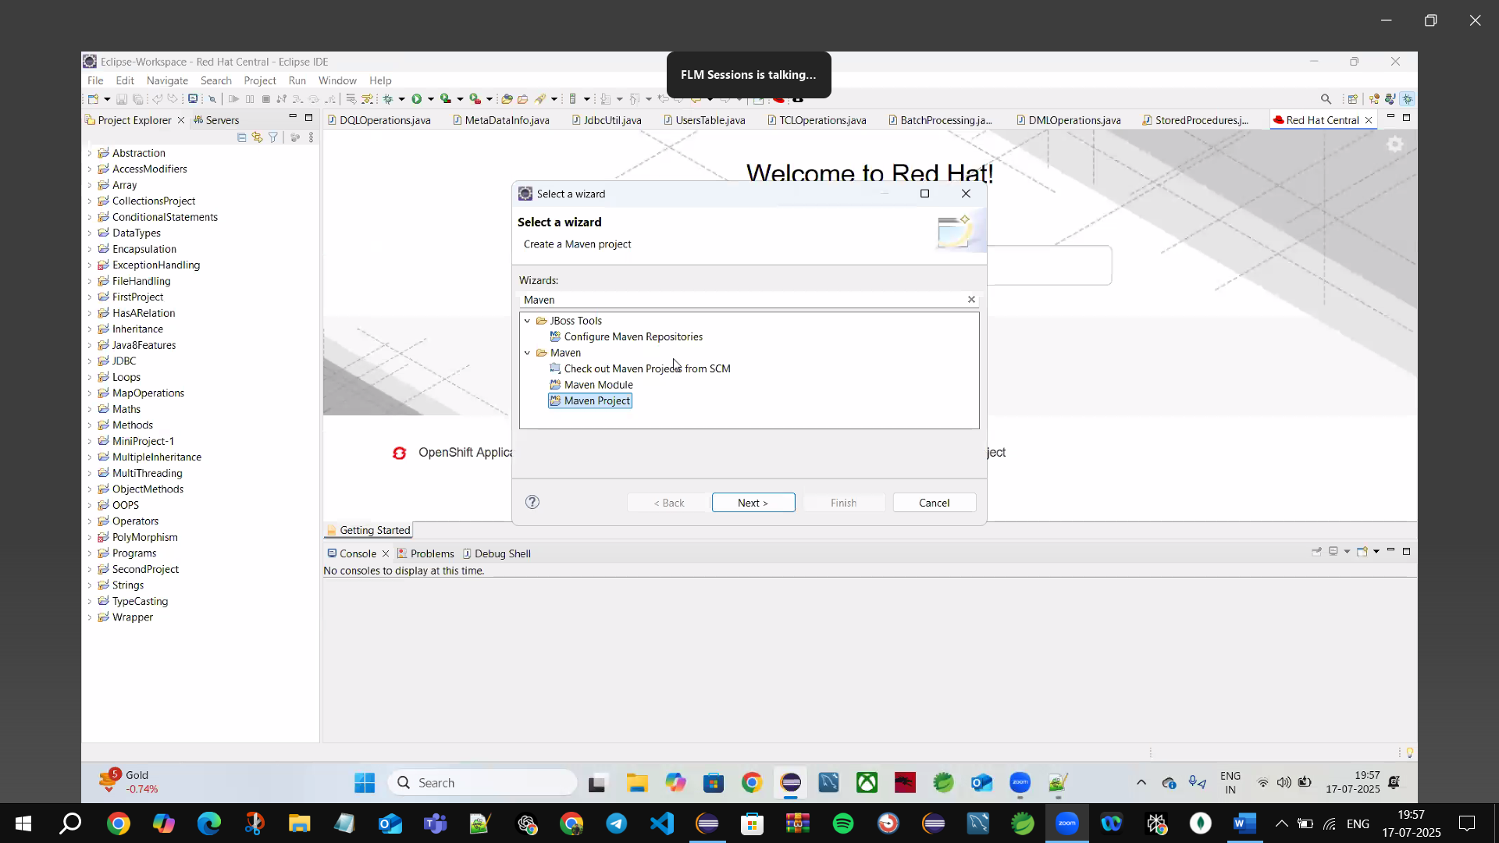

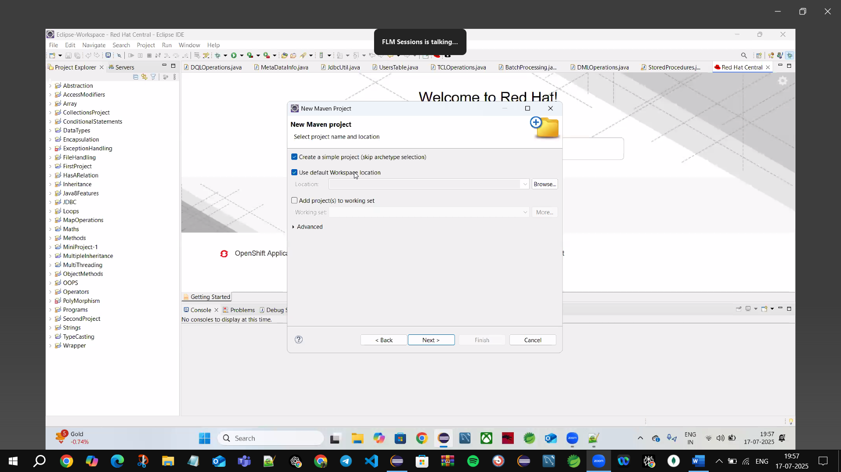

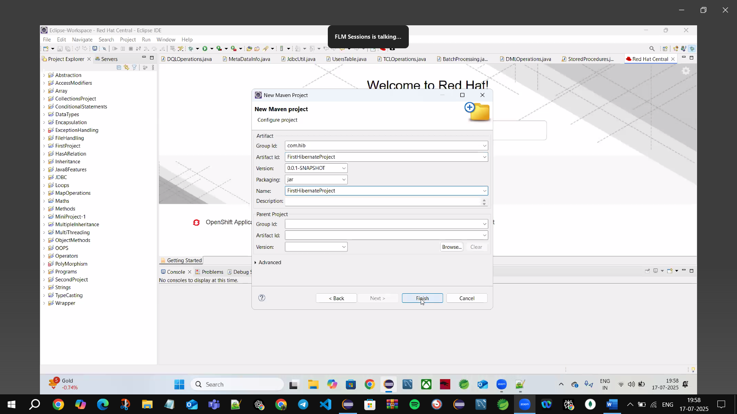

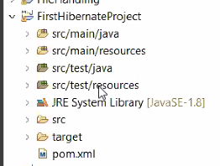

**1.src/main/java**🡪write all our code (.java files)

**2.src/main/resources🡪**write all configuration/properties files

**3.src/test/java🡪**write all unit tests

**4.src/test/resources🡪**write all unit test resources

**5.pom.xml🡪**write all dependencies

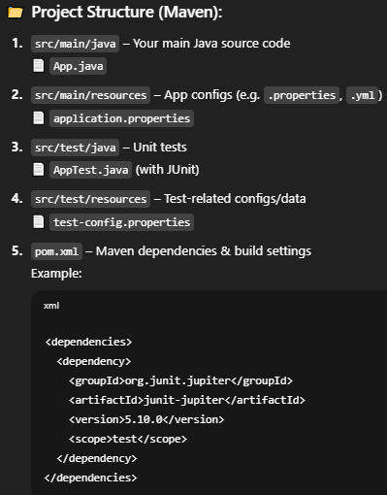

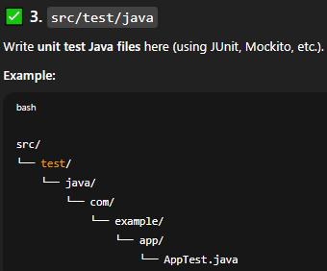

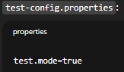

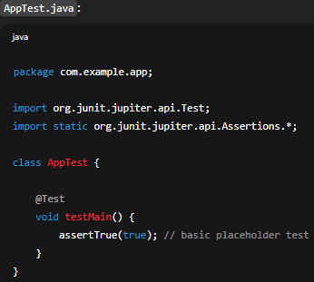

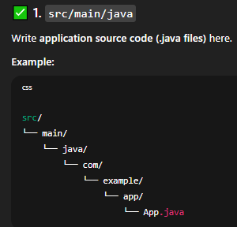com.example.app(package)

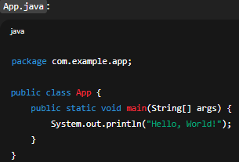

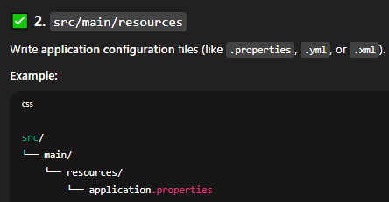

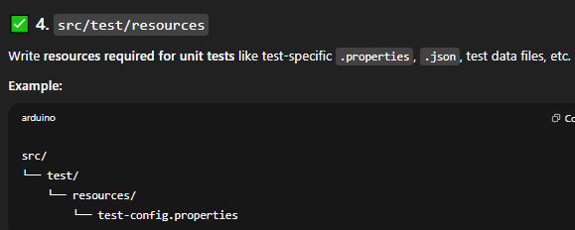

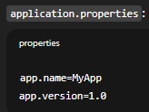

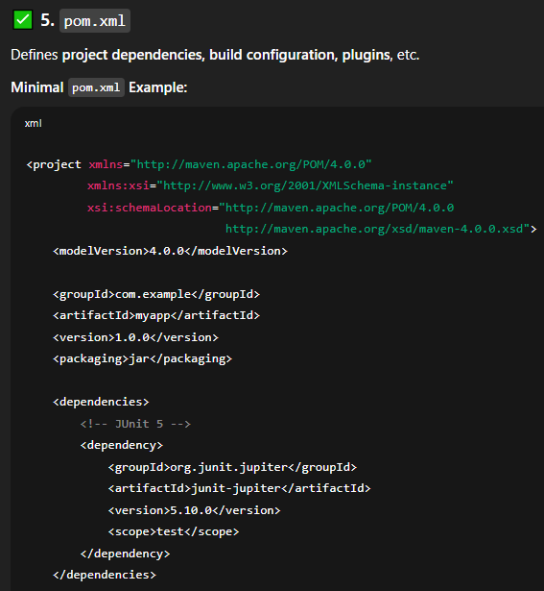

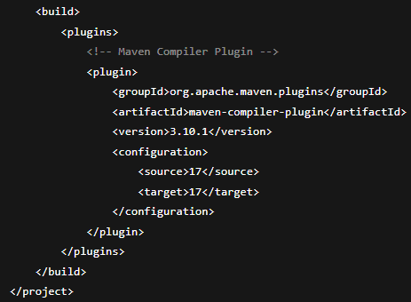

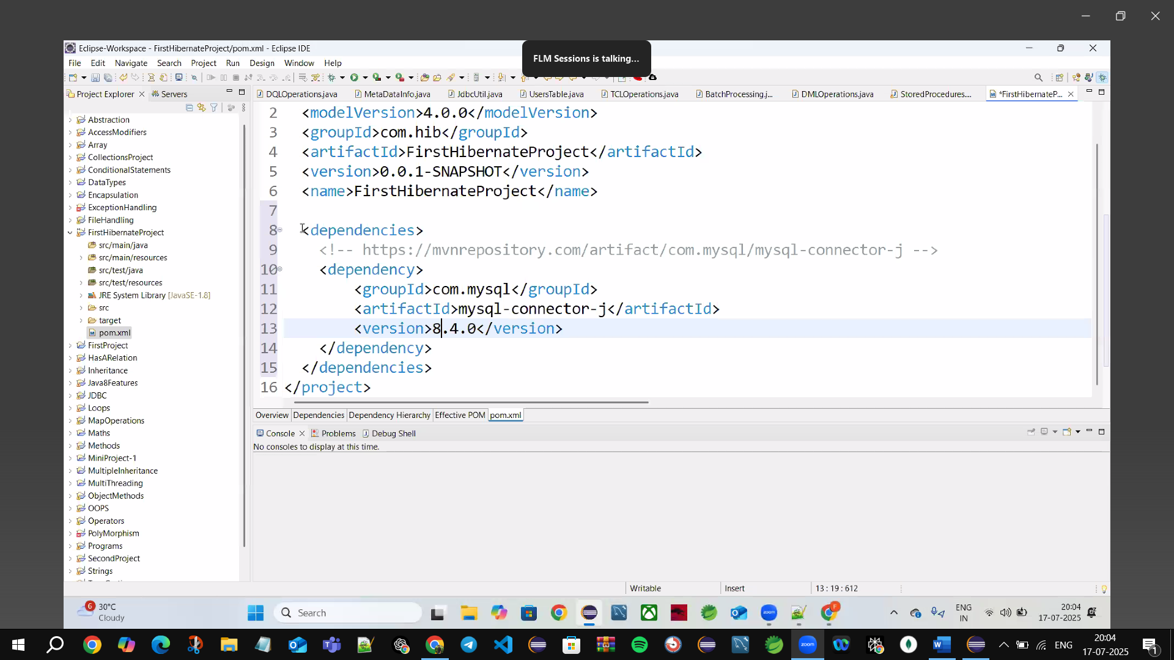

🡪In Real time we use 🡪Maven Project

**<> 🡪open tag**

**</>🡪close tag**

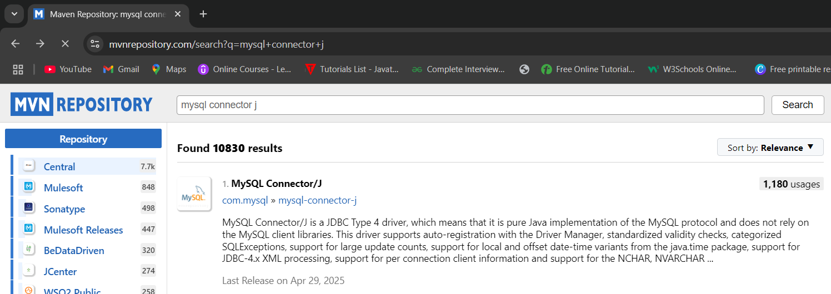

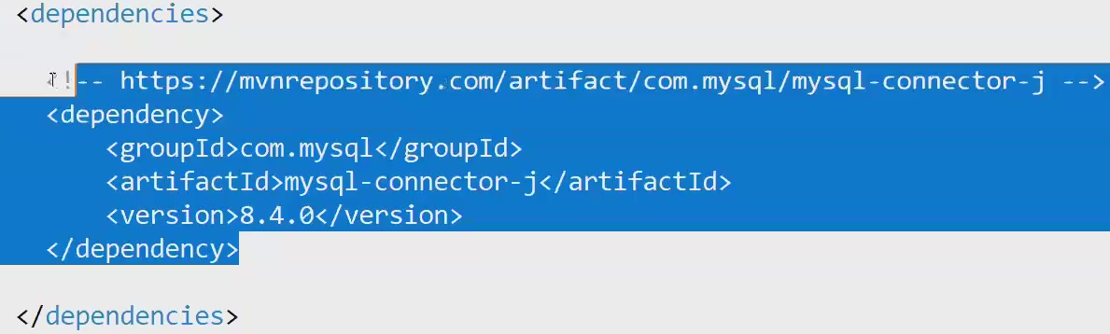

**🡪we can add the dependencies inside** **<dependencies> open**

**“ code …………..”**

**</dependencies>close**

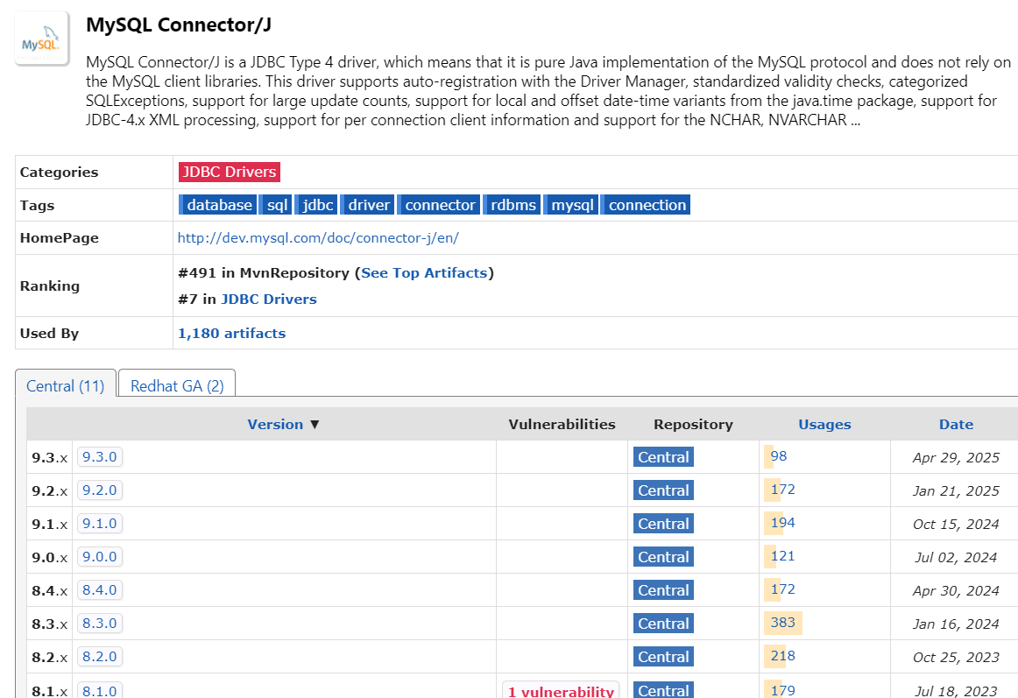

🡪go to Maven Repository🡪search 🡪MySql cj(connector java)

Vulnerabilities🡪(Problems/Bugs)

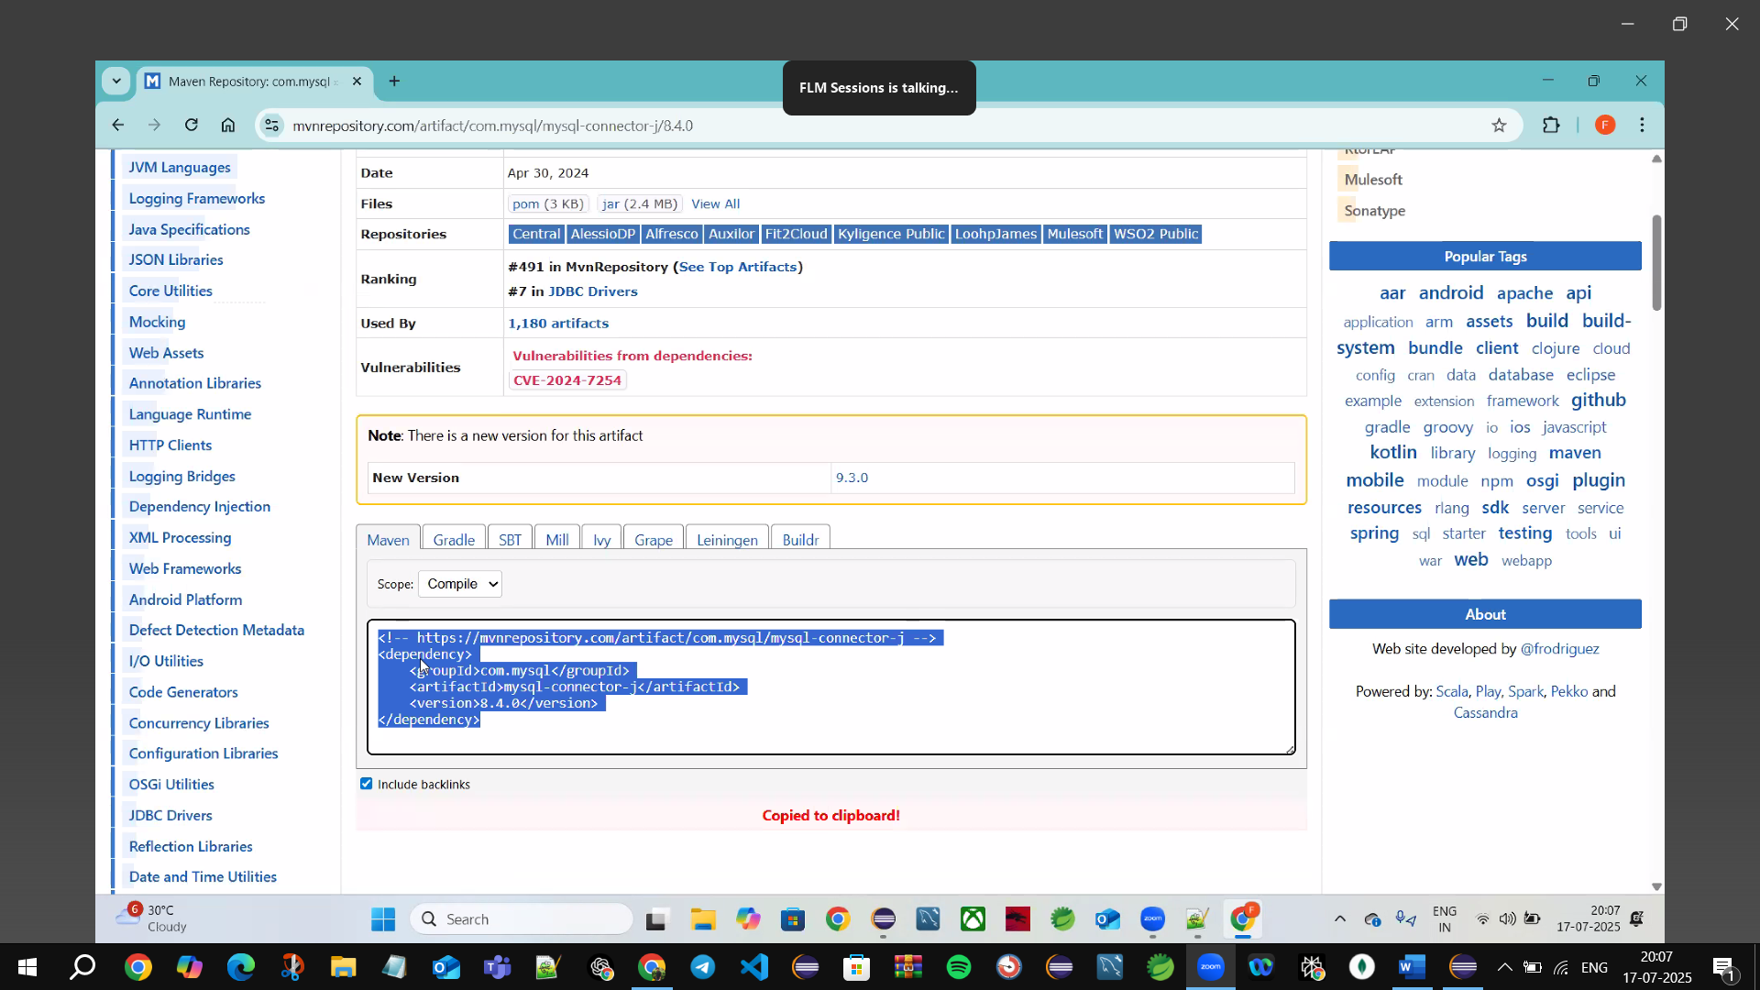

**🡪Get Error in pom.xml🡪**1st right click on your project🡪maven🡪Update Project🡪Force Update of snapshots/Releases 🡪Click Ok

🡪or put **https** instead of **http** or vice versa **(https=http or http=https)**

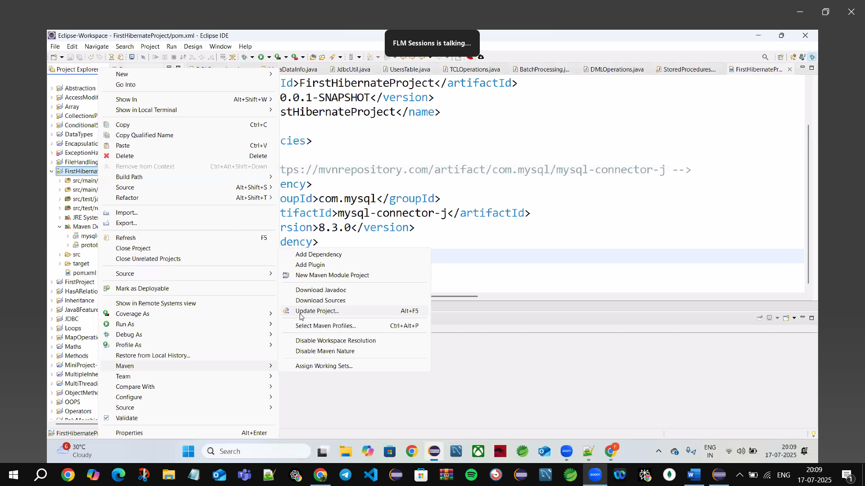



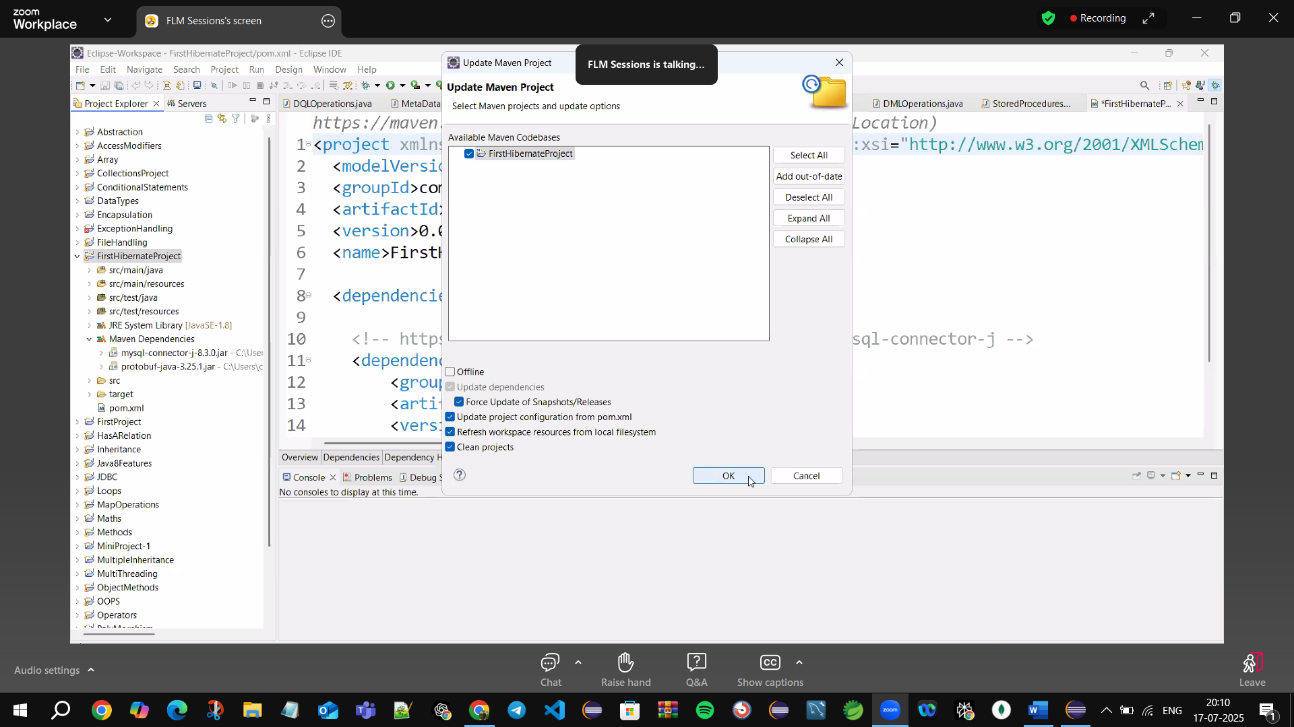

🡪**Create POJO (plain old java object) Class for Employe class**

**🡪all POJO classes we call it as models/Entity**

**com.model/com.entity**

**🡪Class name must match with Table name (not mandatory as class name same as table name)**

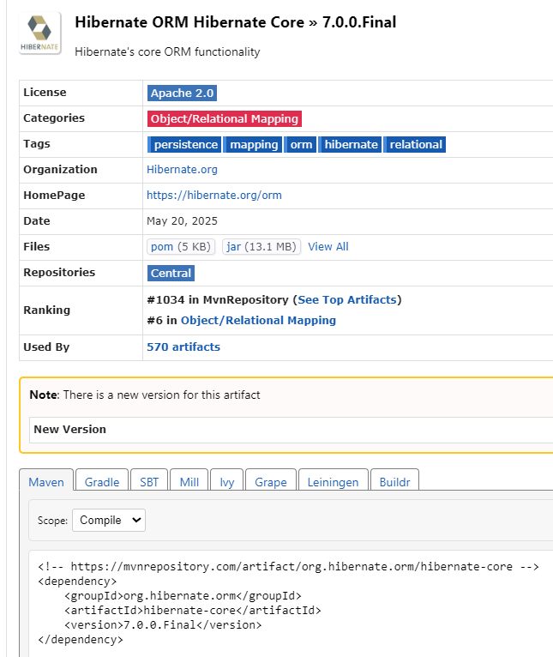**copy the dependency & paste inside pom.xml**

Take🡪**org.hibernate.orm**

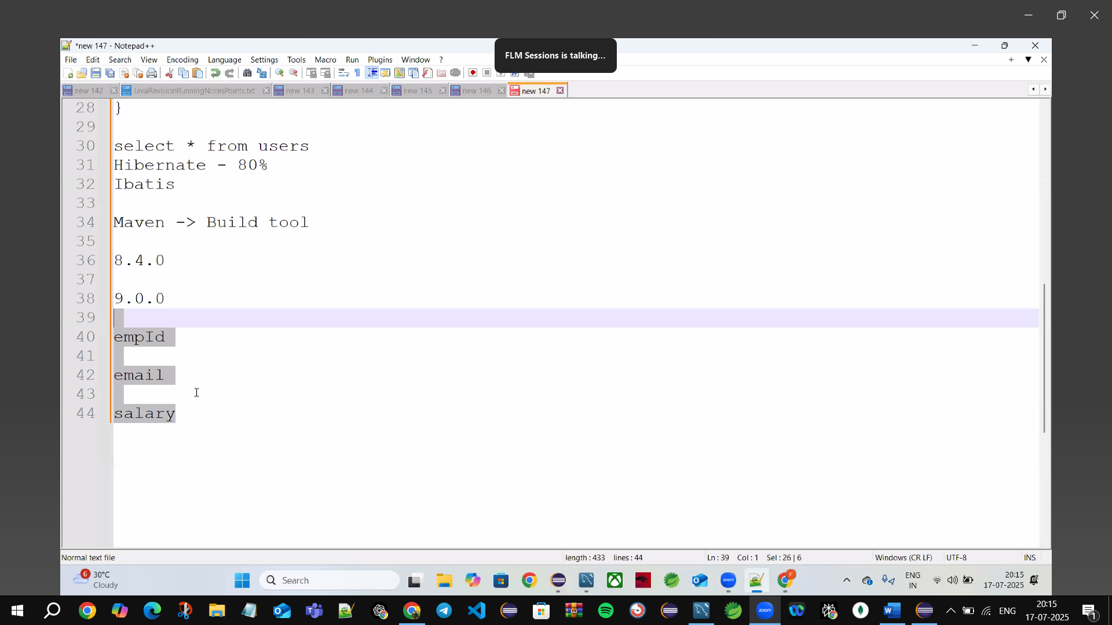

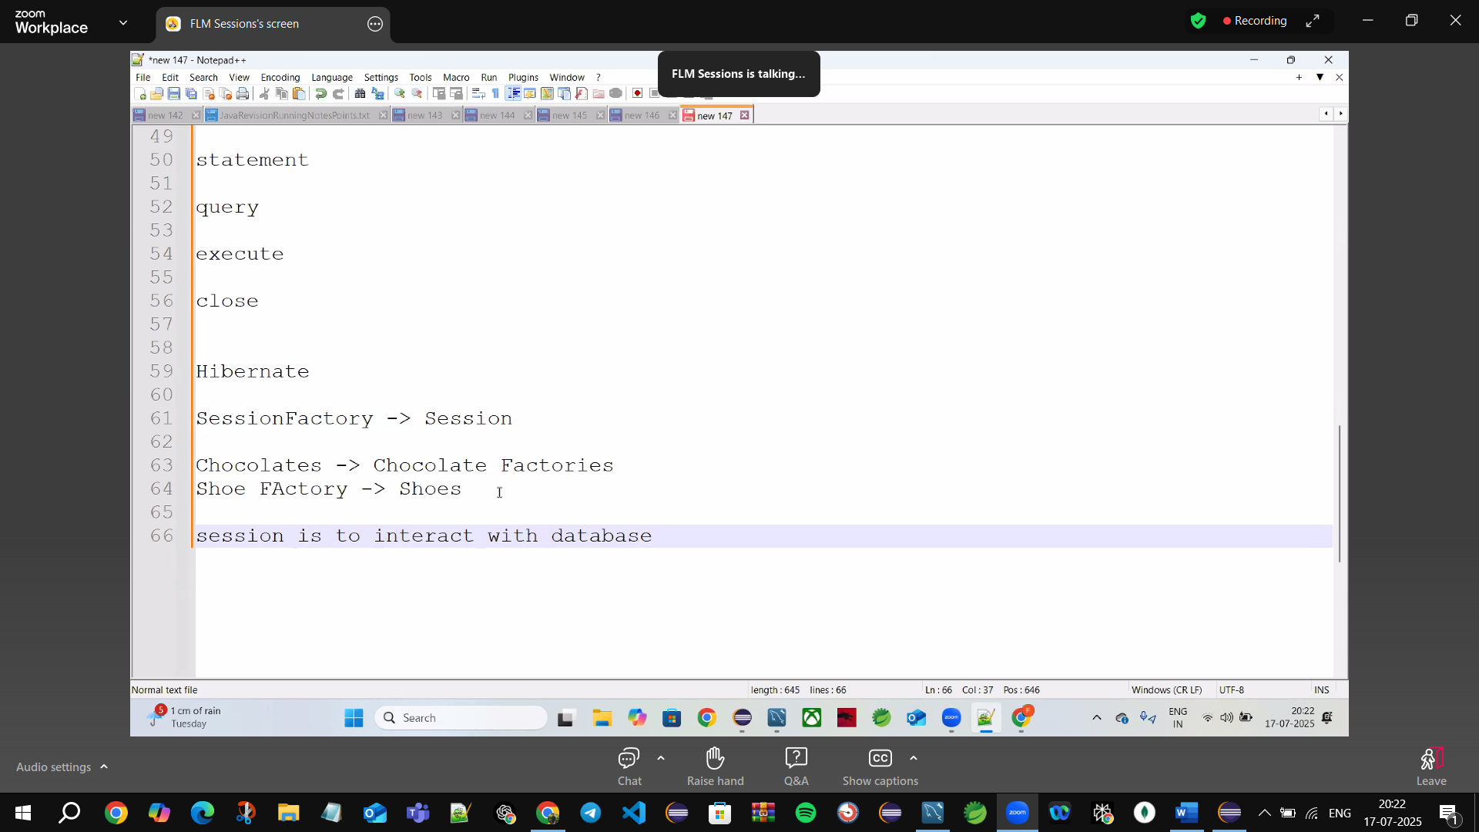

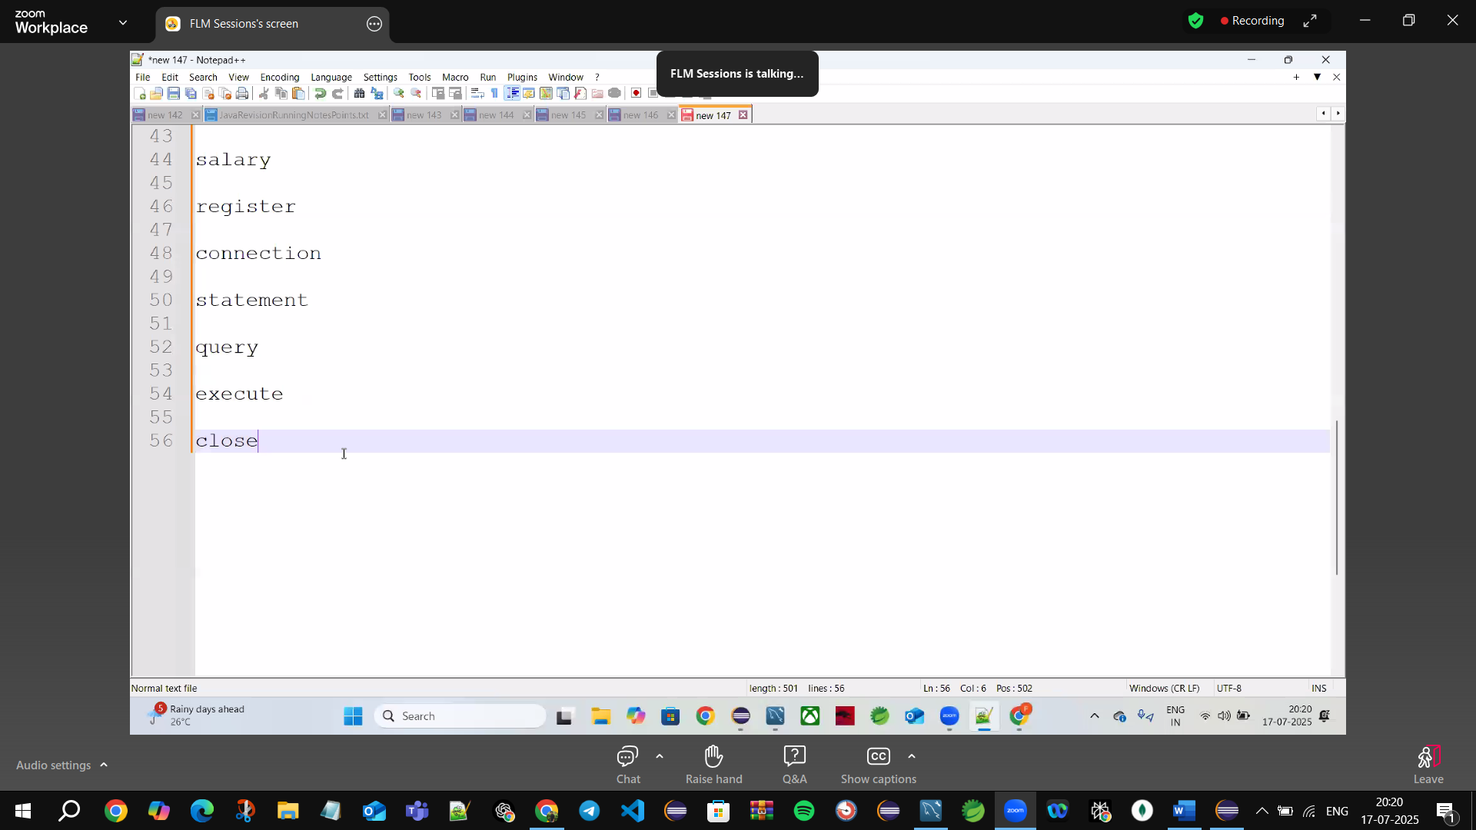

**session🡪is used to interact with the database (D.B)**

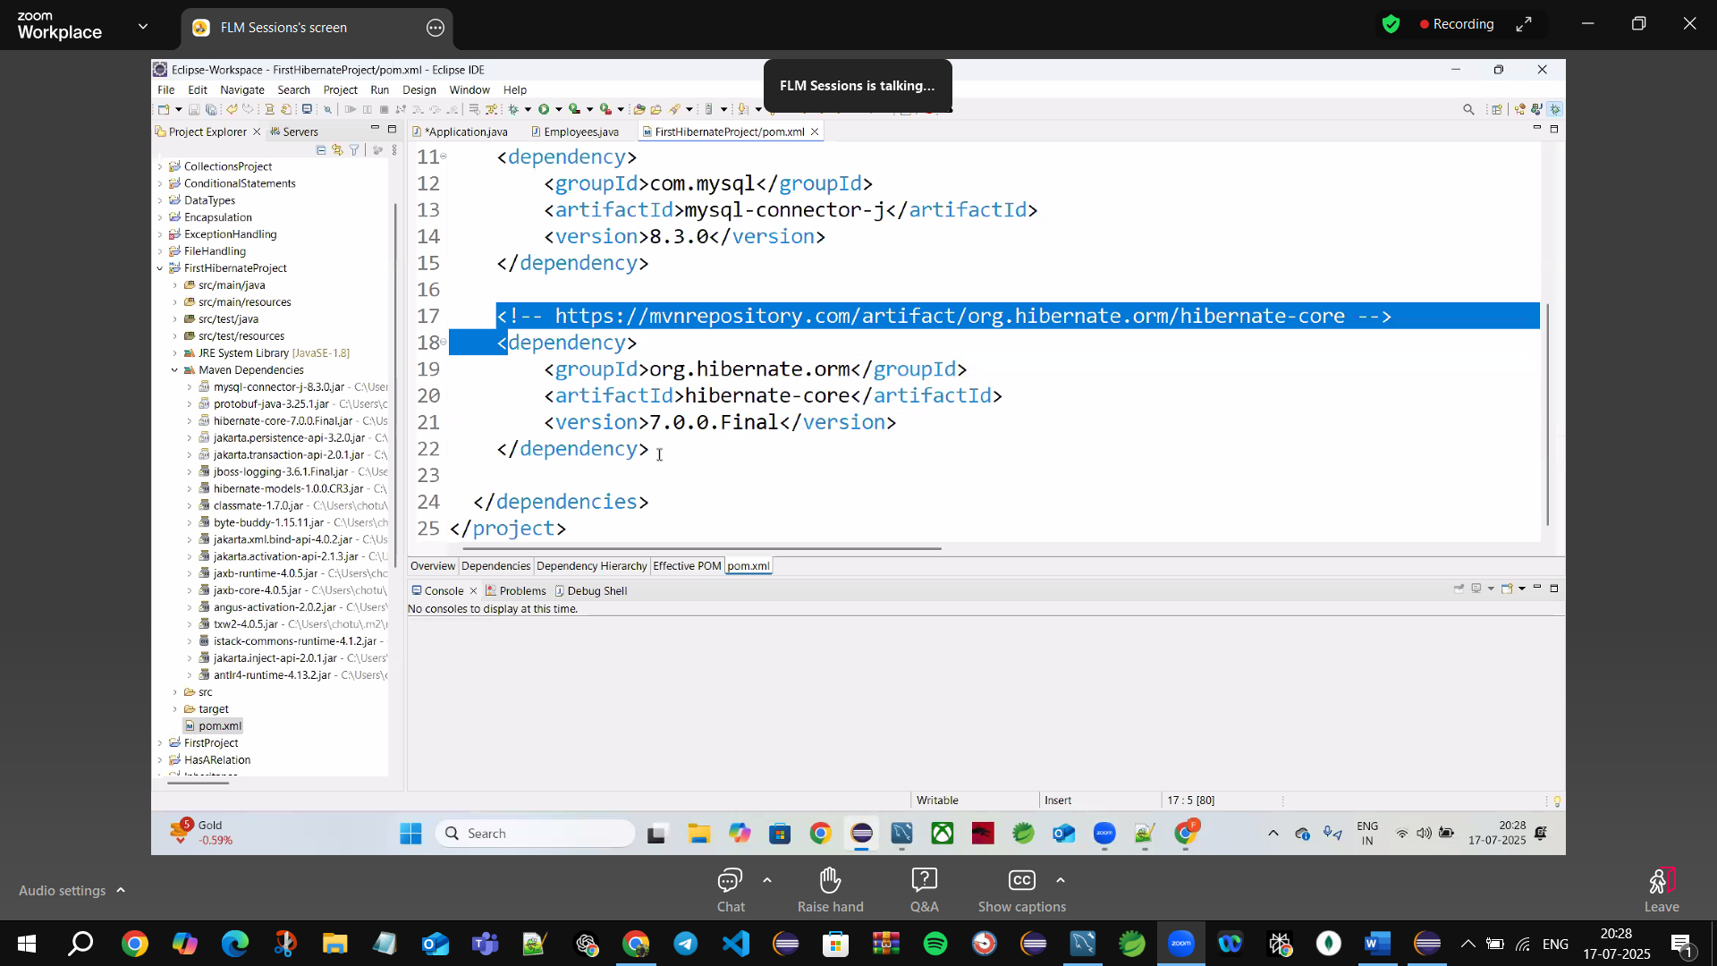

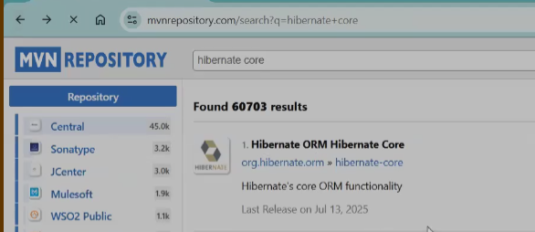

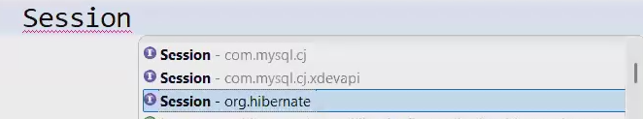

🡪**Session-org.hibernate**

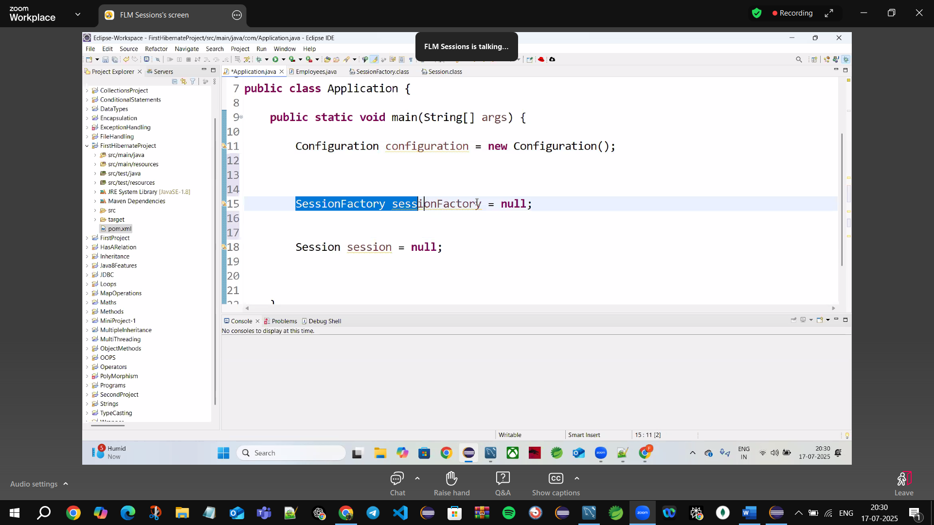

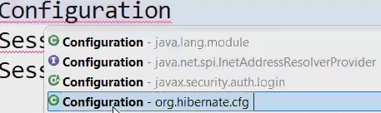

**Configuration**🡪**org.hibernate.cfg**

**🡪everything must** come from **org.hibernate.cfg**

**Configure the Hibernate file**

**src/main/resources🡪Right click🡪new🡪other🡪type🡪hibernate**

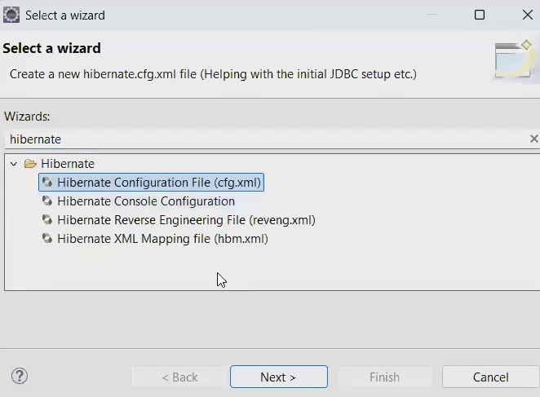

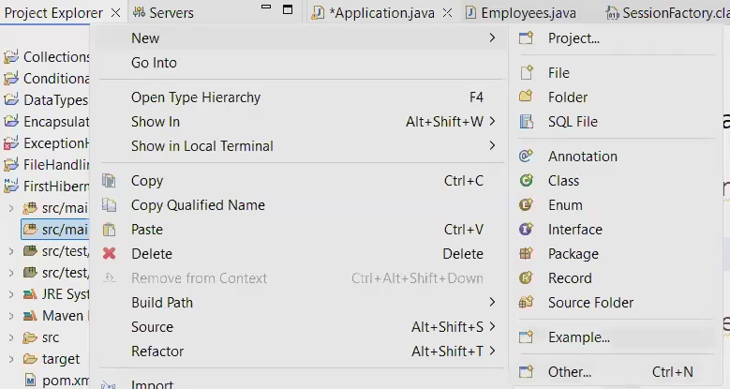

🡪to Download Hibernate🡪go to help🡪Eclipse Market place🡪search Hibernate Tools🡪Enter🡪Install JBoss Tools 4.29.1. Final

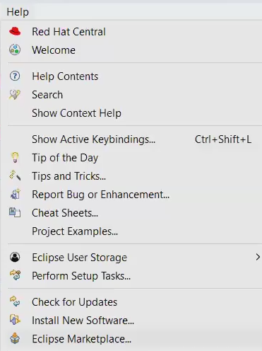

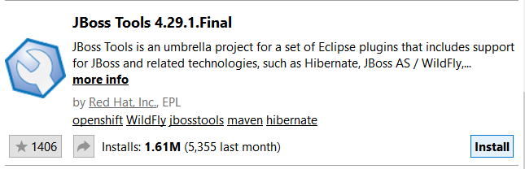

🡪Select only hibernate options in installations process

🡪Install JBoss

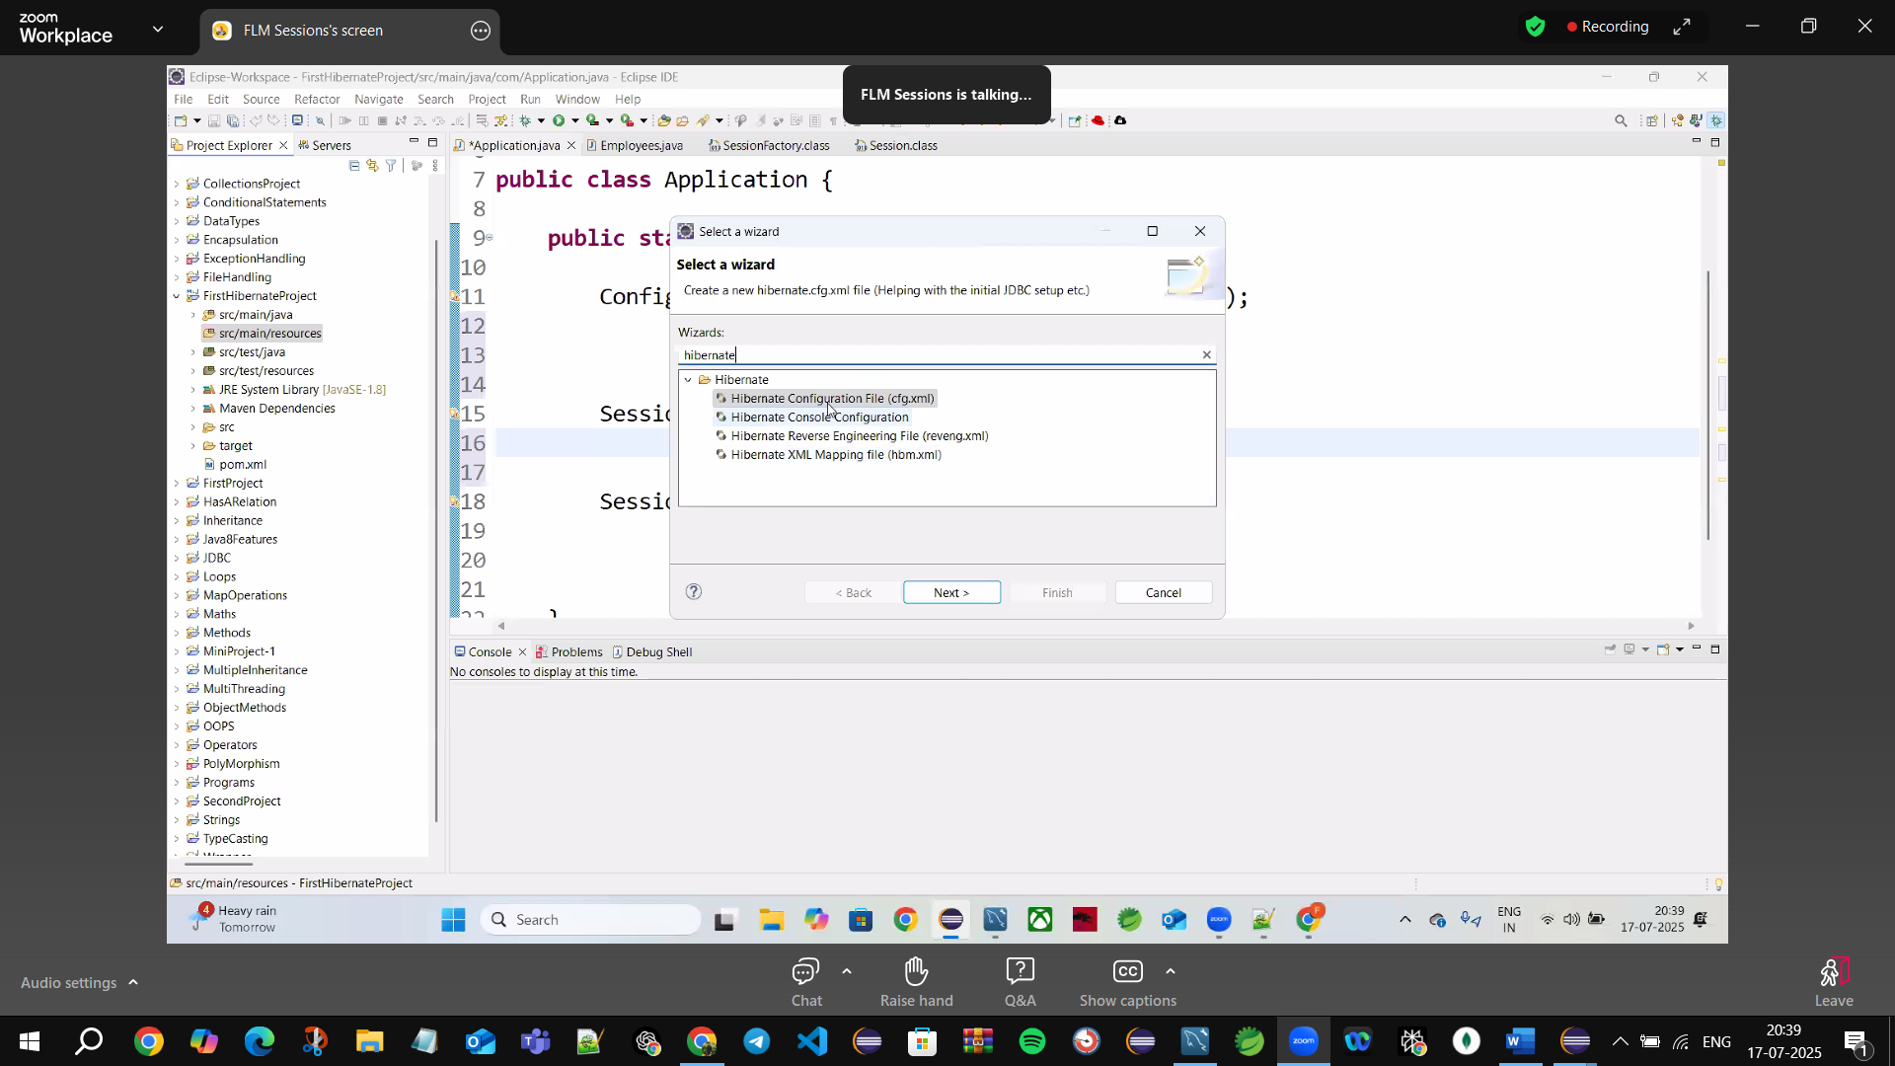

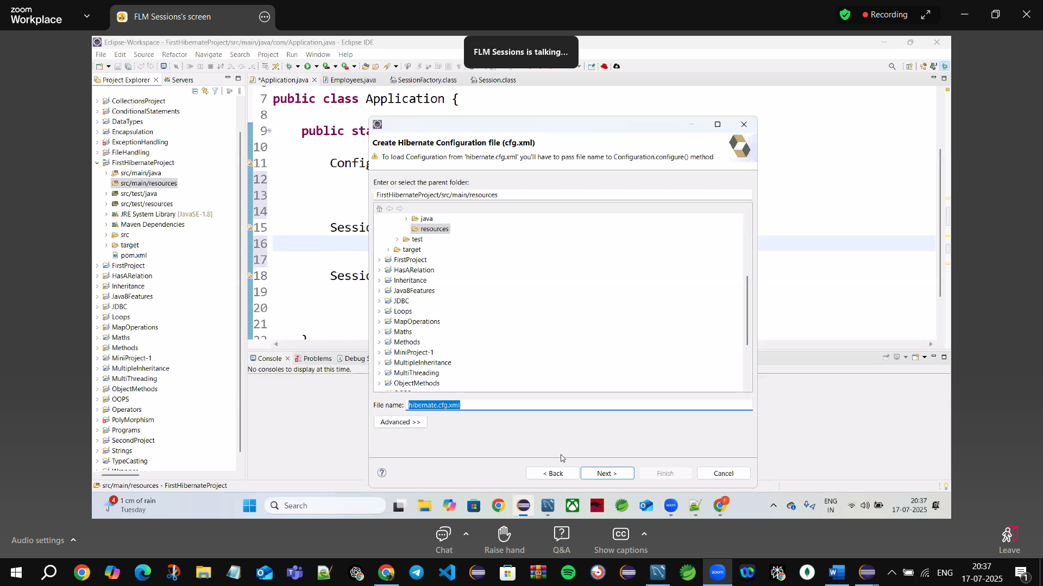

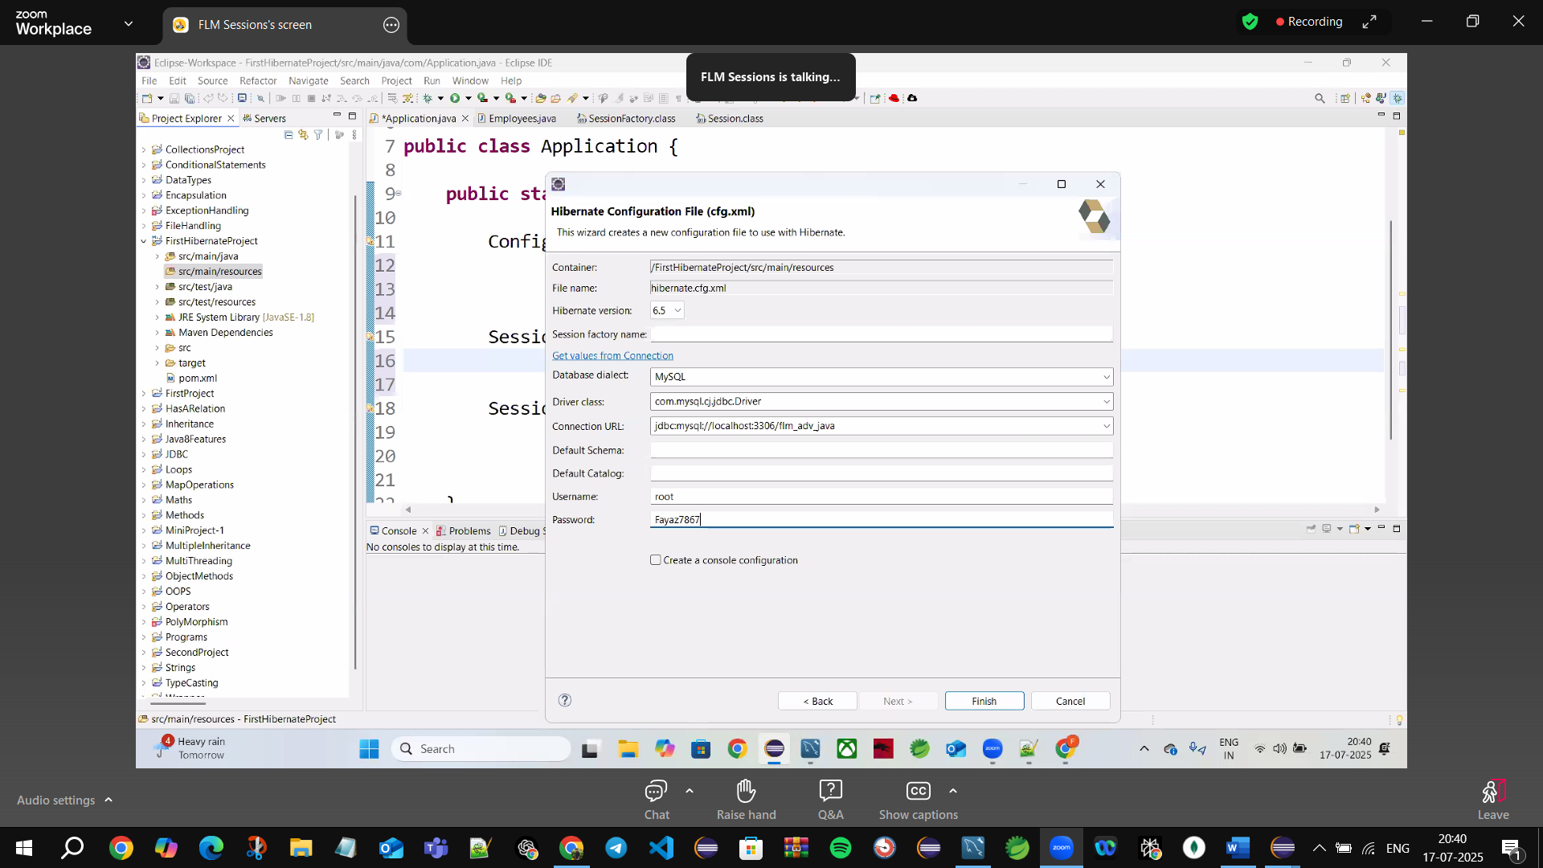

**Dialect:** tell which Database using (Eg: MYSQL)

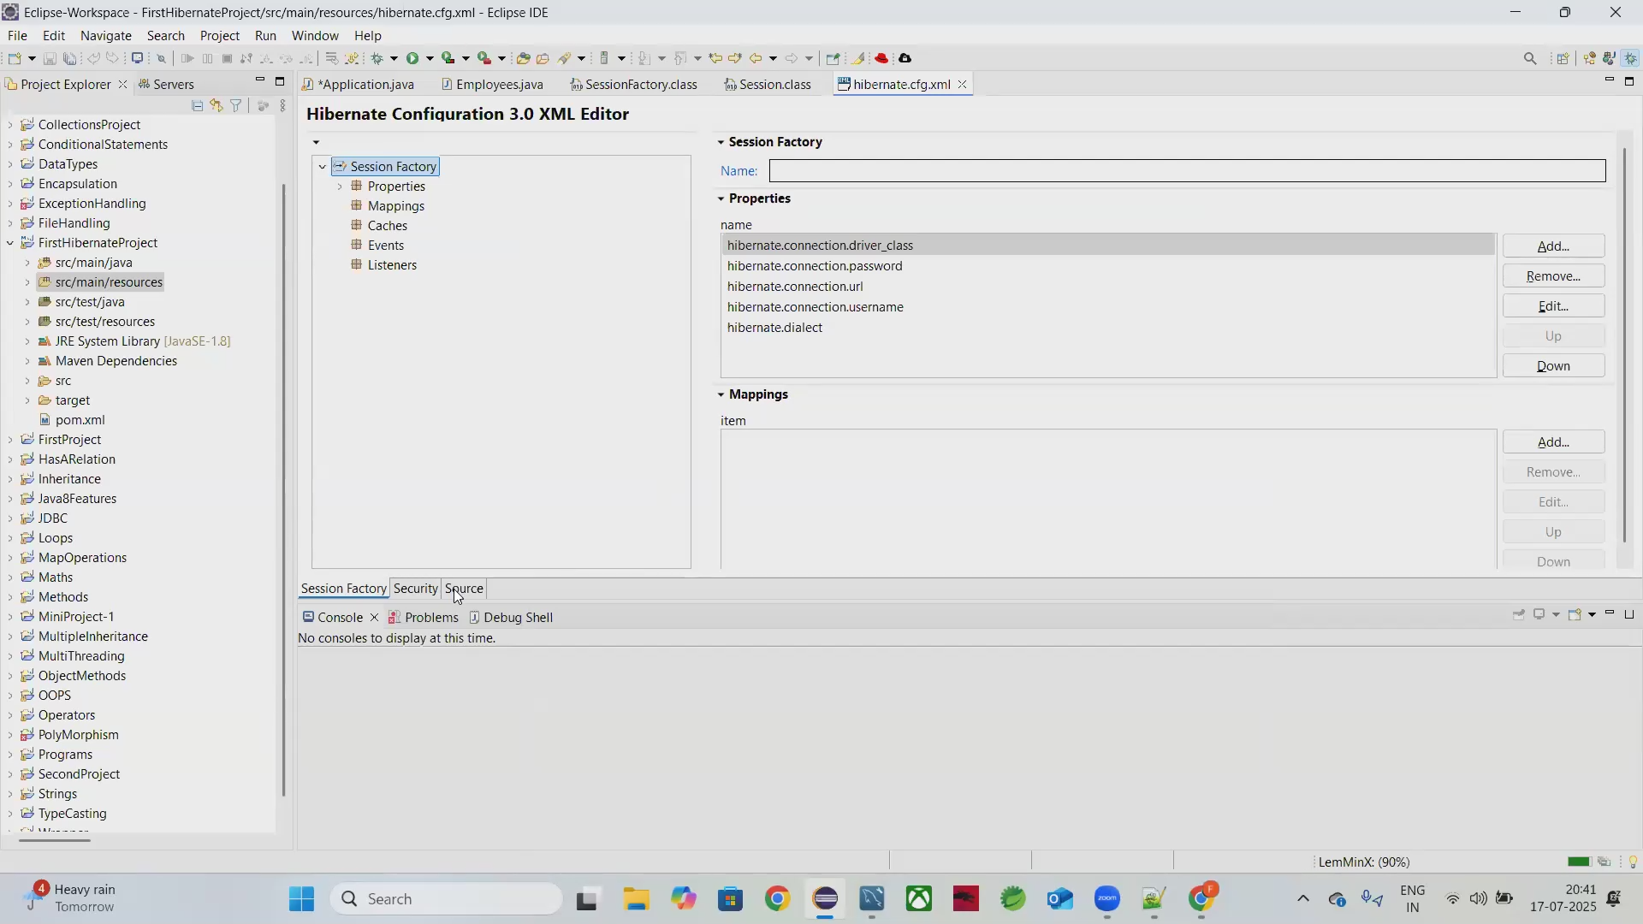

**Click on Source🡪**show actual file (hibernate.cfg.xml)

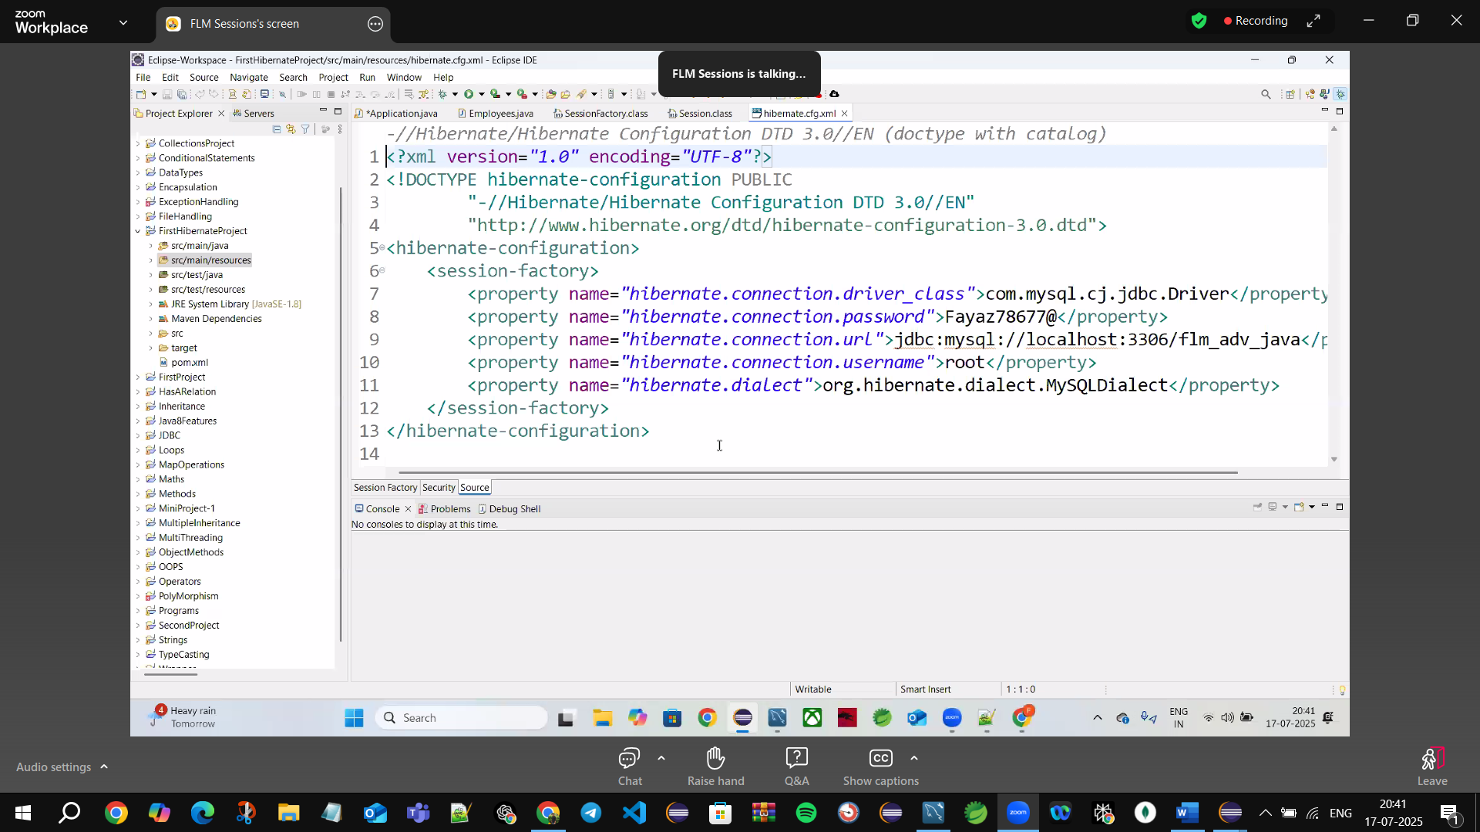

Has 13 lines



1🡪xml file 🡪encode=UTF-8 encoding data



2🡪dtd🡪DOCTYPE definition (defines actual hibernate)

**🡪Need to know//tells** about(**tags**) <hibernate-configuration>

<session-factory>

</session-factory>

</hinernate-configuration>

dtd will go to 🡪http://www.hibernate.otg/dtd/hibernate-configuration-3.0.dtd”>

and bring all required tags from that URL

dtd🡪doctype definition 🡪it’s kind of metadata

**3. <hibernate-configuration>🡪**do some all hibernate configuration here

**4. <session-factory> creating session factory🡪** have actual properties

🡪hibernate.connection.cDriver_Class

🡪hibernate.connection.password

🡪hibernate.connection.url

🡪hibernate.connection.username

🡪hibernate.dialect

**Dialect🡪kind of translator (translate b/w hibernate & MySQL)**

**🡪For each project we have to setup once as (hibernate.cfg.xml file)**

**🡪pass configuration file to configuration**

**🡪Create a session factory**



**These all are methods🡪configure(), buildSessionFactory(),openSession();**



**Call objects 🡪bcz all are instance methods**



**Create Employees class**

**Session.save(emp)🡪previous version upto 6 then 7 removed**

**Save replace with persist()**

**persist()🡪prepare to insert**

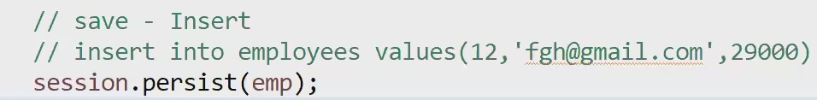

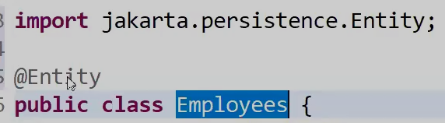

**🡪Employees java obj class map to SQL Employees TABLE( ORM)**

**🡪@Entity means🡪 class mapped to database table**

**Jakarta🡪package name/company name (previous javax🡪 upgraded to jakarta)**



**🡪add employees class with annotated class**

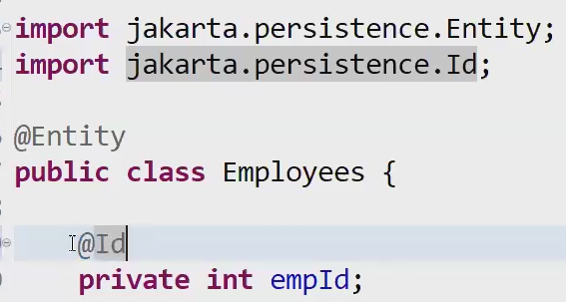

**🡪Every class has 1 primary key**

**🡪@Id means 🡪understand that it’s a primary key of the table**

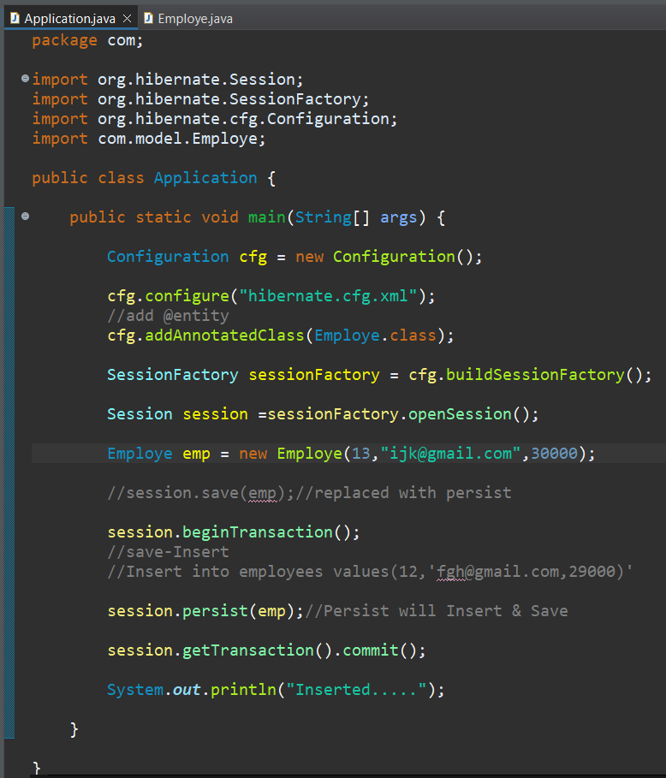

**✅ So the accurate description is:**

* persist() → **prepare to insert**
* commit() → **actually insert/save to DB**

**🧠 Think of it like:**

🔹 persist(emp); = “I **want to save** this employee.” (Hibernate tracks it)  
🔹 commit(); = “**Now actually save** everything I’ve marked.”

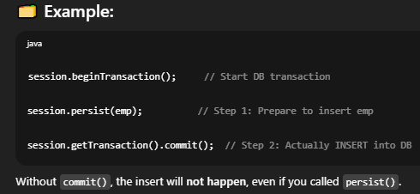

**✅ In One Line:**

🔸 **persist()** = *“Mark for saving”*  
🔸 **commit()** = *“Actually save it to the database”*

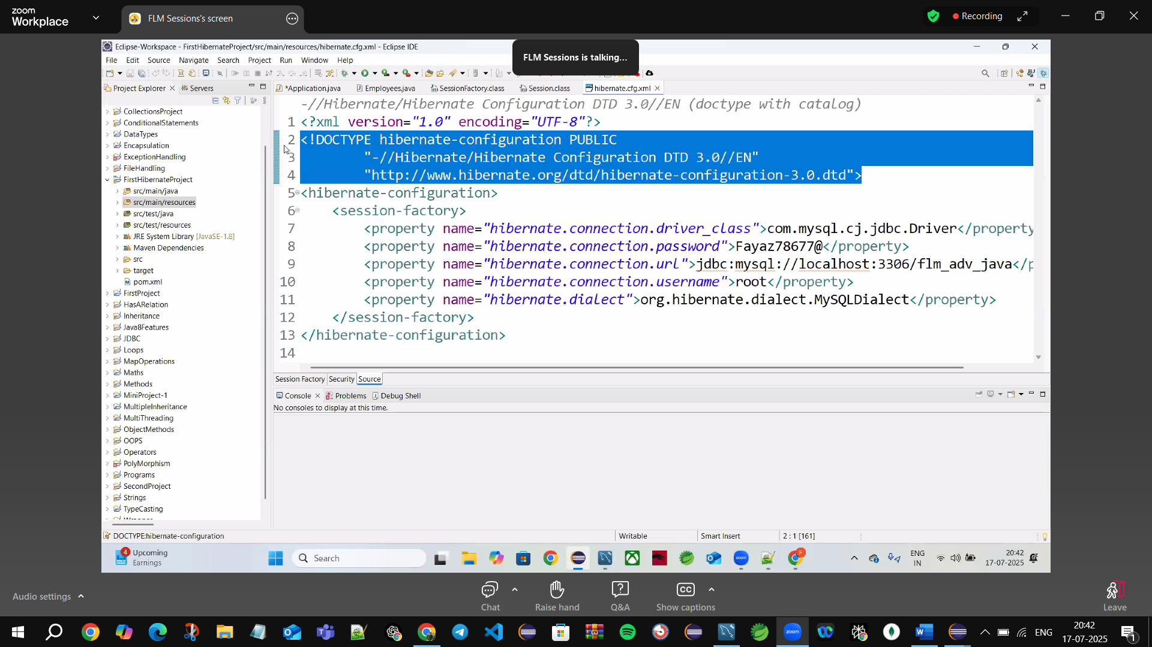

Dock type definition



**import** jakarta.persistence.Entity;//Package name

@Entity



//add @entity

cfg.addAnnotatedClass(Employe.**class**)



**import** jakarta.persistence.Id;

@Id

**Warning logs**

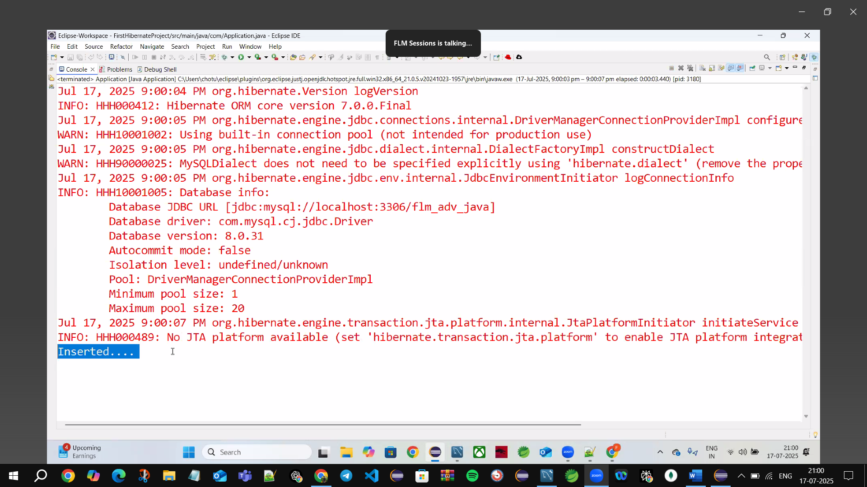

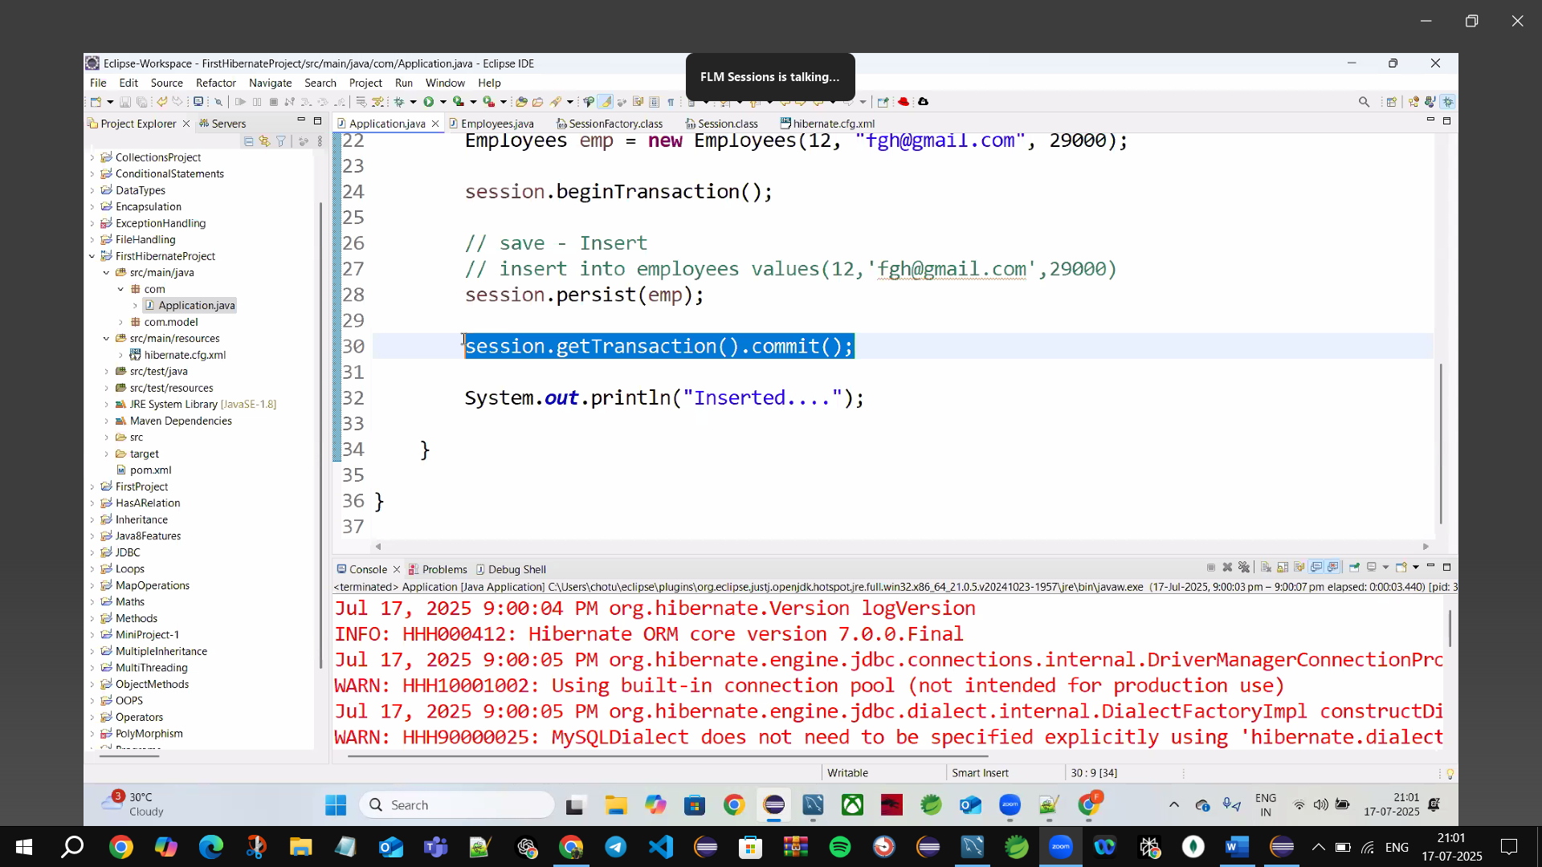

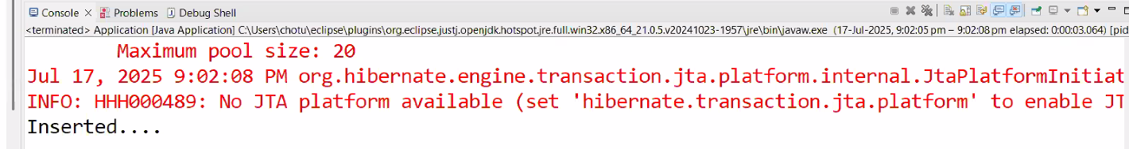

**Data only comes after** session.beginTransaction()🡪begins tx

session.persist(emp);//do all operations update/delete(persist🡪insert)

session.getTransaction(). commit ();🡪commit tx()

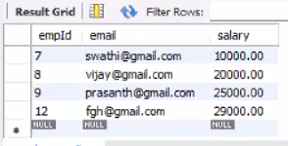

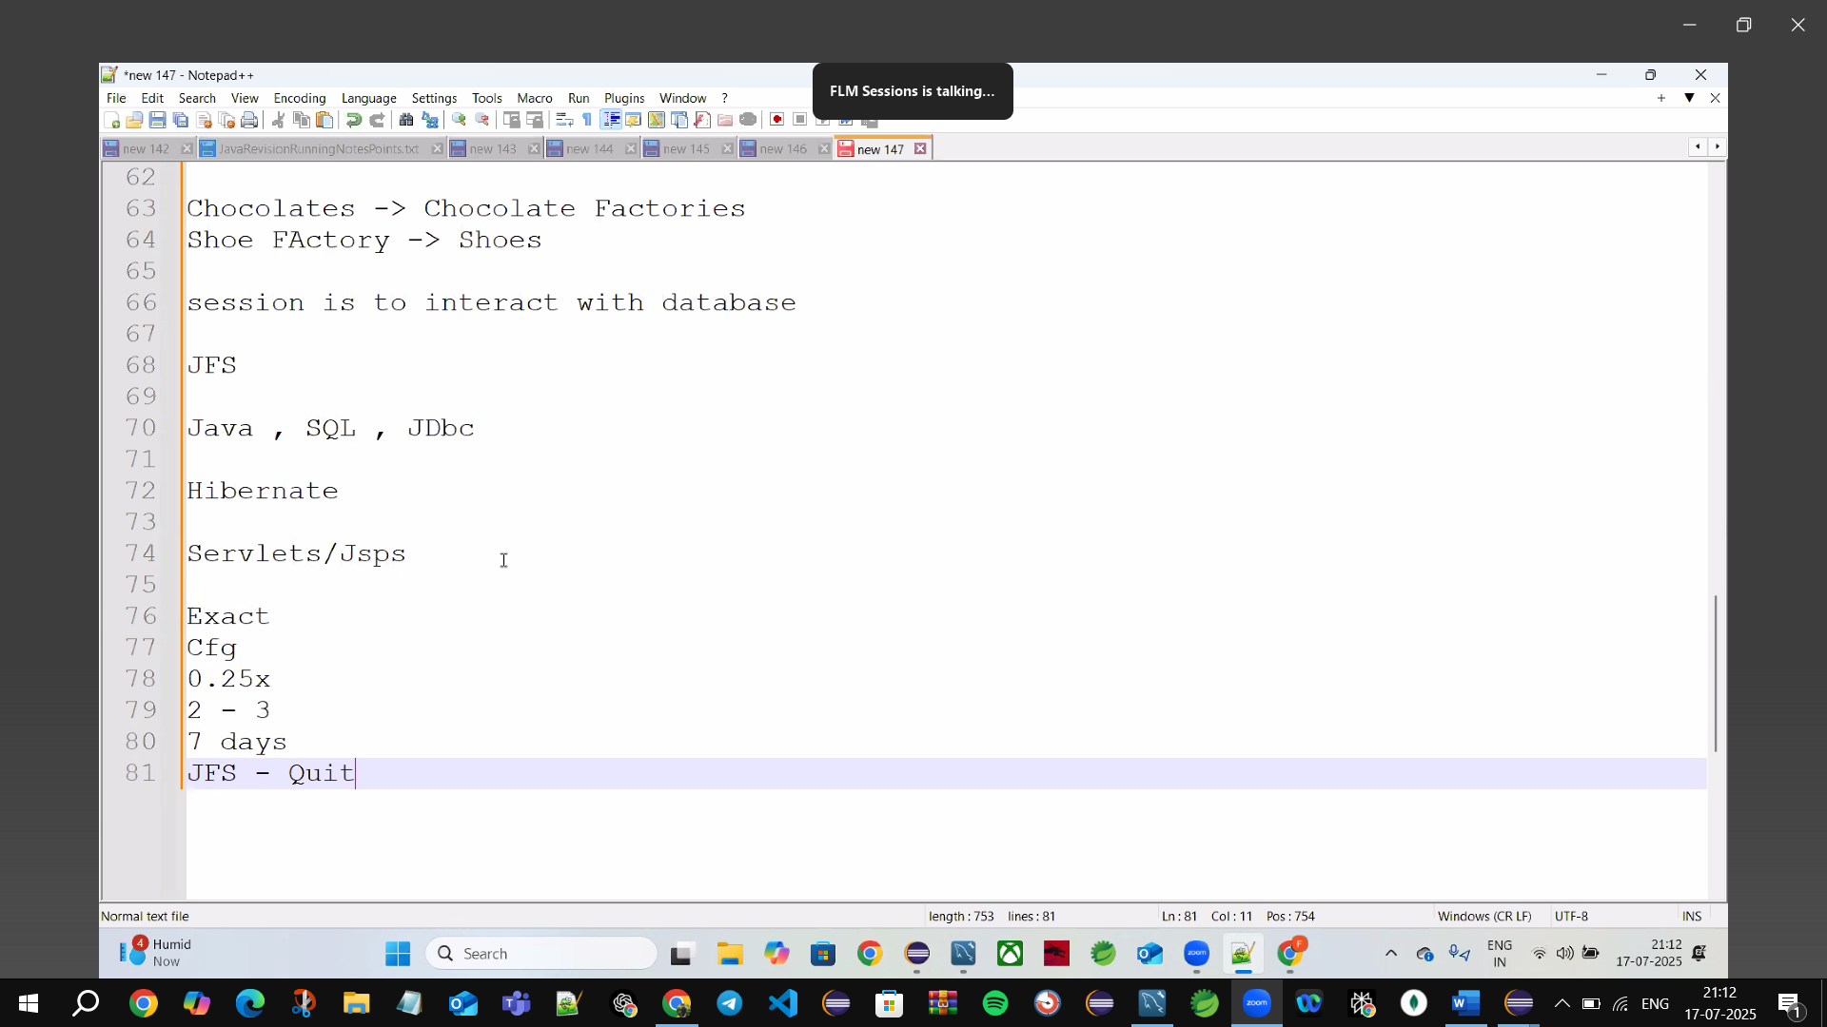

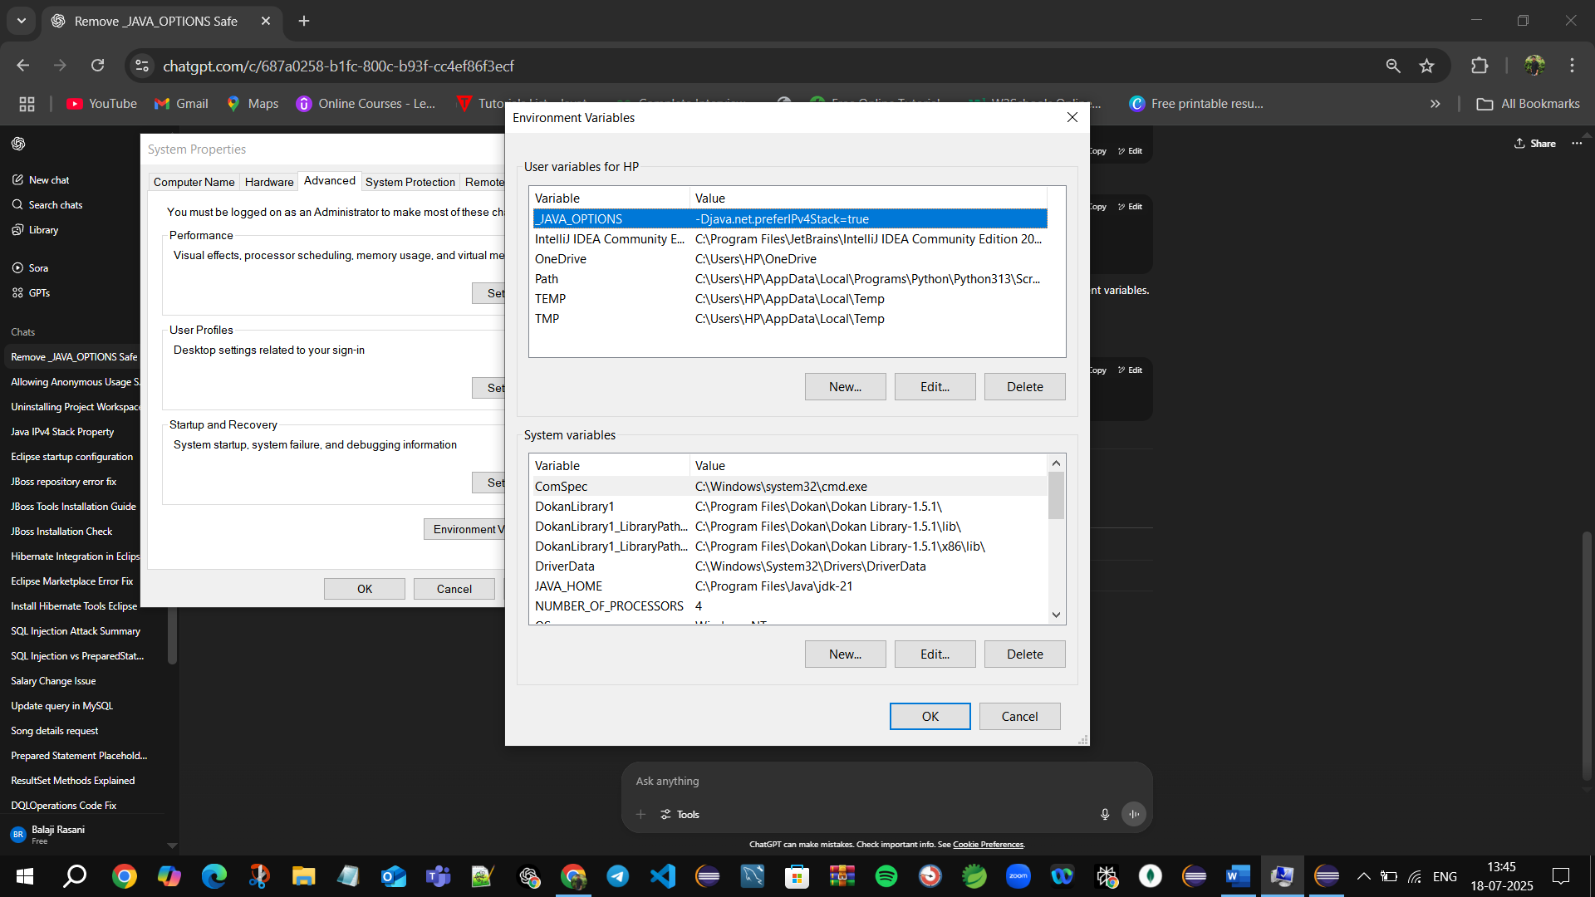🡪Add path but don’t work (only Reinstall Eclipse then its work to install Jboss4.29.1)

🡪So Many ppl’s leave java bcz of errors they thought not to fix it